# Installation and configuration guide for Thingworx monitoring

## Background

tsample is small, customized tool which plays similar role to telegraf. Its focus is on gethering Thingworx performance metrics. Historically, this tool also supports collecting OS level performance metrics but it's highly recommended to collect OS level performance metrics by using telegraf.

## Recommanded deployment architecture

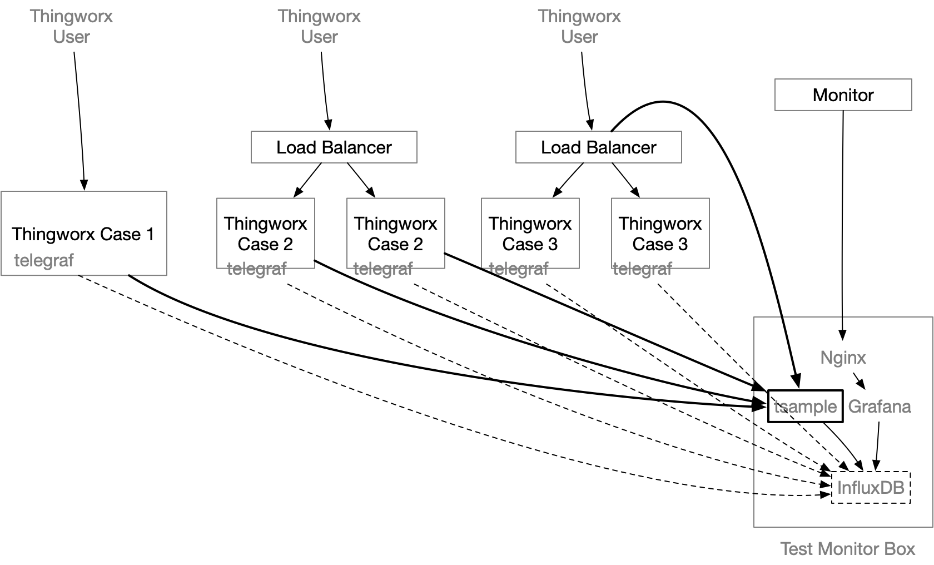

tsample can be deployed in the same box where Thingworx tomcat is running, but it's recommended to deploy it on a seperated box to minimize any performance impact caused by the collector.

tsample supports export to InfluxDB and/or local file. In this document, it is assumed that InfluxDB will be used for monitoring purpose. Please note that this is not the same instance of InfluxDB being used by Thingworx (if configured).

### Supported Platform

tsample supports and has been tested on windows 2016, MacOS 10.15, Ubuntu 16.04 and Redhat 7.x. It's anticipated to work on more general Ubuntu/Redhat/Mac/Windows release.

In case you need a build to run on Resperry PI, please let me know.

### Notice

This tool was built before the author knows telegraf and therefore it includes the capability to collect basic OS level performance metrics such as CPU usage, Memory usage and Disk usage. However, it's strongly recommended to use telegraf to do so.

this document will focus on explaining how to use it to collect Thingworx metrics.

## Configuration File

### Where to store configuration file

tsample will pickup configuration file in following sequence:

* from command line
* ./tsample -c <path to configuration file>
* from environment
* Linux:
* export TSAMPLE_CONFIG=<path to configuration file>  
  ./tsample
* Windows:
* set TSAMPLE_CONFIG=<path configuration file>  
  tsample.exe
* from default location
* tsample will try to find a file with name config.toml from same folder in which it starts.

### How to craft a configuration file

You can use following command to generate a sample file:

./tsample -c config.toml -e

or:

./tsample -c config.toml --export

A file with name config.toml will be generated with configuration sample. You can then adjust its content with following guide.

### Configuration file content

#### Format

Configuration file must be in toml format

#### title and owner section

Both sections are optional. The intention of these two sections is support doc tool in future.

#### TestMachine section

This is sectin is required and it defines where this tool will run.

|  |  |
| --- | --- |
| Name | Note |
| testid | Indicates the machine where this tool is running. |
| sampling*cycle*inseconds | Indicates the interval time of performance metrics sampling – typically 30, 20 or 10 seconds. Default value is 30 seconds, if not included. Values less than 10 seconds or greater than 60 seconds are not recommended. |
| sampling*timeout*inseconds | Indicates the timeout for RESTful calls to ThingWorx. Default value is 10 seconds if not included. It's recommended to set this value between 10 and sampling_cycle_inseconds. |
| testmachine.onetime_sampling | (Optional) Recommend leaving it at default. |
| testmachine.repeat_sampling | (Optional) and you can just change each metric to false; Recommend using telegraf to get OS level metrics. This feature will be removed in the next release, only remaining in the current release for code stability purposes. |

#### thingworx_servers section

This section is where you define targeted thingworx applications. Multiple Thingworx servers can be defined with same or different metrics to be collected.

|  |  |
| --- | --- |
| Name | Note |
| alias | It’s optional, but strongly recommended, that you give it a meaningful name. It would be a tag value in InfluxDB. A meaningful value will help you to define the performance dashboard more easily. |
| host and port | Indicates where ThingWorx server is running. In case alias is missed, then a combination of host and port will be used to distinguish the metrics result in InfluxDB as a tag value. |
| protocol | Choice of https and http. It should be the protocol used by the targeted ThingWorx application |
| application | Should always be Thingworx – changing this is not supported |
| app-key | A valid appKey in ThingWorx, the associated user should have enough permission to access the performance metrics. |

##### thingworx_servers.metrics sections

Underneath each thingworx_servers section, there would be many metrics. In default example, following metics have been included:

* ValueStreamProcessingSubsystem
* DataTableProcessingSubsystem
* EventProcessingSubsystem
* PlatformSubsystem
* StreamProcessingSubsystem
* WSCommunicationsSubsystem
* WSExecutionProcessingSubsystem
* TunnelSubsystem
* AlertProcessingSubsystem
* FederationSubsystem

You can add your customized metrics, as long as the result follows same data shape. The default data shape has 3 columns:

|  |  |
| --- | --- |
| Column Name | Note |
| name | STRING type |
| description | STRING type |
| value | INTEGER or LONG, but this tool can accept NUMBER (64bit float) as well. |

If the output Data Shape exceeds above limitation, the tool will likely not work properly.

|  |  |
| --- | --- |
| Name | Note |
| url | Required - end point of RESTful API for each performance metric |
| split*desc*asprefix | Required - set to true |
| name | The measurement name in InfluxDB(or file name if result is exported to local file). |
| enabled | Required - set to true or false. Use to easily control which metrics will be collected with minimal configuration changes |
| options | Optional - Control which metrics are collected from this subsystem, instread of all. Example: ["totalWritesQueued", "totalWritesPerformed","queueSize"] |
|  |  |

### result_export_to_db section

This section defines target InfluxDB as a sink of collected performance metrics.

|  |  |
| --- | --- |
| Name | Note |
| using_udp | Deprecated - please keep set to false. Will be removed in next release as udp will not be supported going forward |
| server_name | Name (or IP Address) of InfluxDB. |
| port | Port for InfluxDB to communicate in HTTP protocol. It's typically 8086 |
| database | Where your collected metrics will be stored. |
| enabled | Set to true if you want to use InfluxDB as the storage. Otherwise, it should be false. |

### result_export_to_file section

This section defines target file storage for collected performance metrics.

|  |  |
| --- | --- |
| Name | Note |
| folder_name | Desired location for performance metrics file to be stored. |
| auto*create*folder | If the folder does not exist, then it will be automatically created if this is set to true |
| enabled | Set to true if you want to use a local file for storage. Otherwise set to false. |

## Grafana configuration example

### Monitor Value Stream

#### Step 1, Connect your grafana to InfluxDB

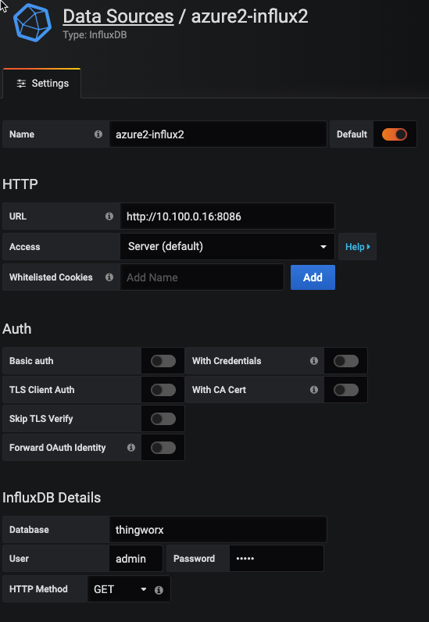

#### Step 2, create a new dashboard and then new query

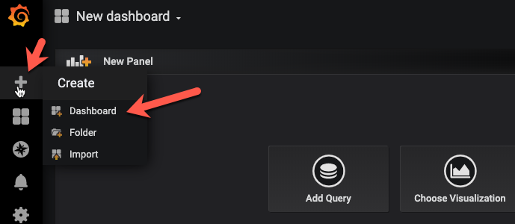

#### Step 3, A new query

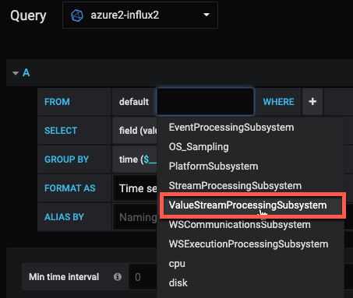

Depending on which metrics you defined to collect in the tsample configuration file, you would see a different choice of measurement in Grafana. Here, we will use ValueStreamProcessingSubsystem as an example.

#### Step 4, Choose right platform and provider

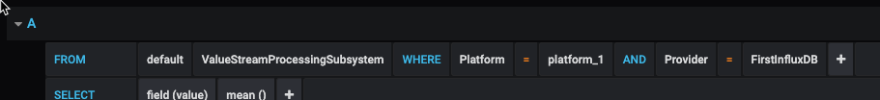

Some metrics is depending on database storage provider, like: value stream and stream.

#### Step 5, Choose metrics figures

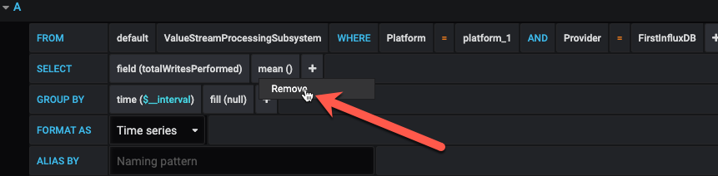

select "remove" to get rid of the default 'mean' calculation.

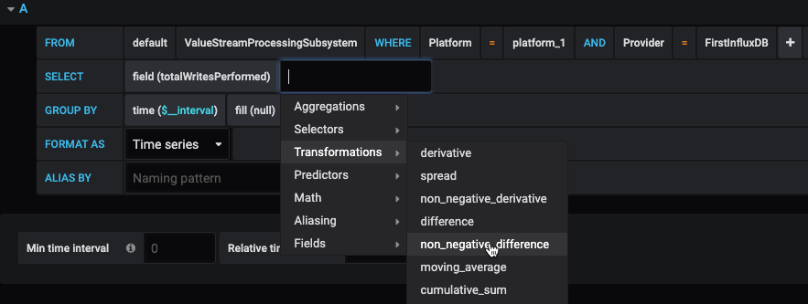

select non_negative_difference from Transformations. Using this transformation, Grafana can show us the speed of writes.

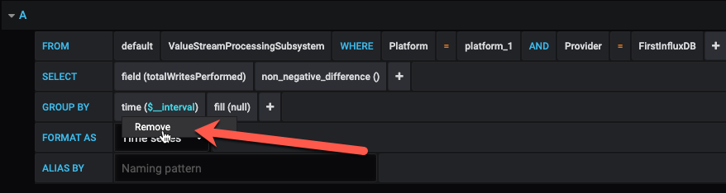

then, remove the default GROUP BY time clause.

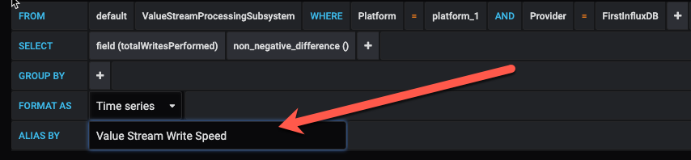

Assign a meaningful alias of this query

#### Step 6, Add another query

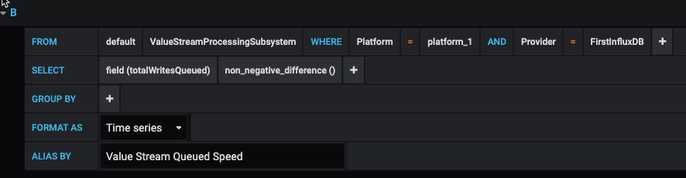

You can add another query as 'Value Stream Queued Speed' by following exactly same steps.

#### Step 7, Assign Panel Title

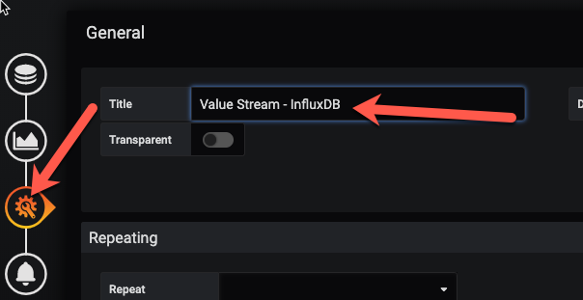

#### Step 8, Review Result



Let's go back to dashboard page and select 'last 15 minutes' or 'last 5 minutes' from top right coner. It should show a result similar to the chart below.

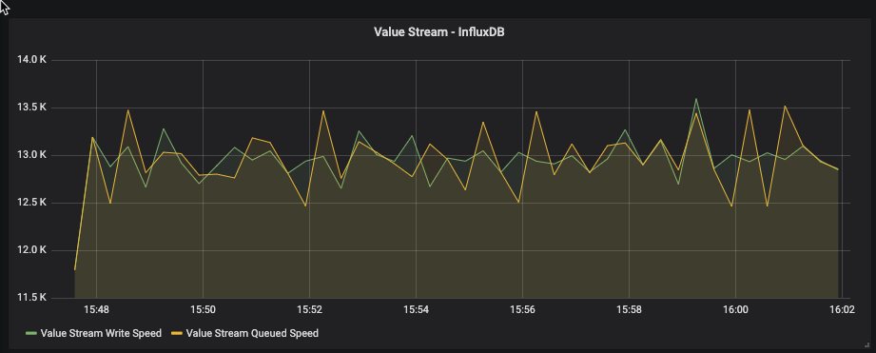

#### Step 9, Save dashboard

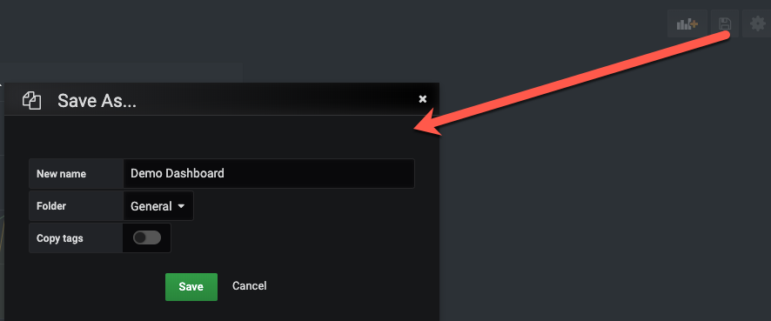

Don't forget to save your Dashboard before we add more panels.

#### Step 10, Refine the panel

It's difficult to figure out the high-level write speed from above panel and let's enhance it.

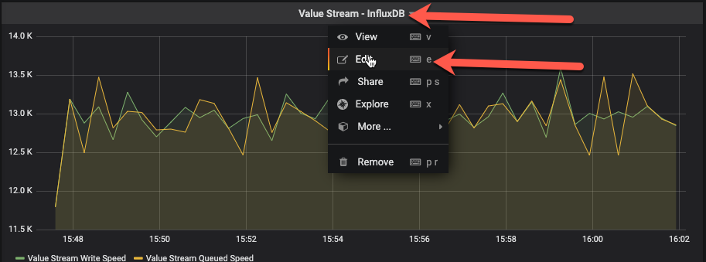

Add a new query with following configuration:

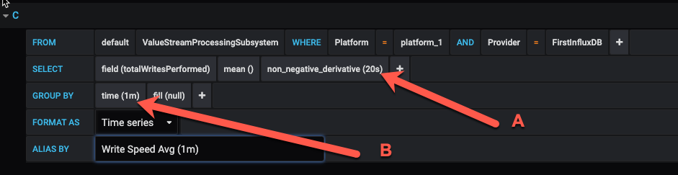

In above query, there are two additional figures: 20s and 1m, How do you choose?

20s should be as same as sampling_cycle_inseconds in your tsample configuration file. If you choose a different value, then you would end-up with a miss-leading results (It's not a difficult math problem though. :) )

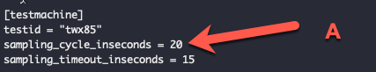

Larger values such as 1m may give you a smoother result but could also hide system instability. 1m should be a good choice for most case.

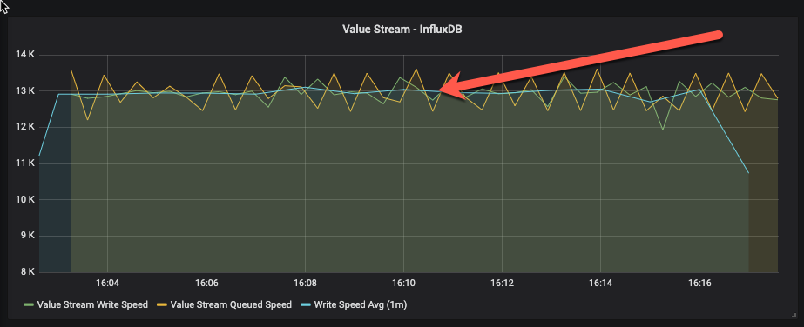

With this new query, it's much identical to figure out what's the average write speed in current testing.

Tips: If your sampling_cycle_inseconds is 30s, then you may not need this additional query. The following image is a sample at the 30s interval time. You would not need an additional average query to get a smooth write speed.

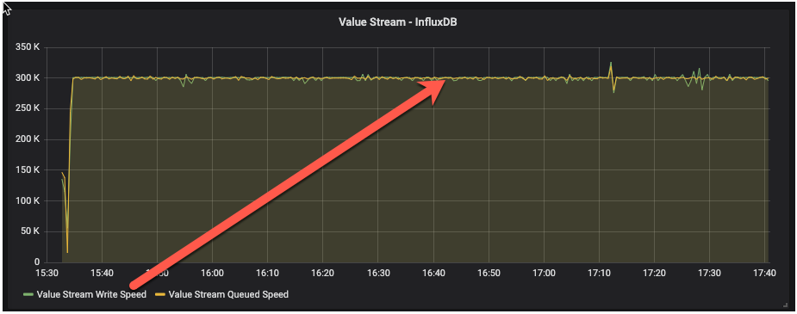

The next example is a sample at 10s interval time. Without additional queries, you may not be able to get a meaningful understanding of the write speed.

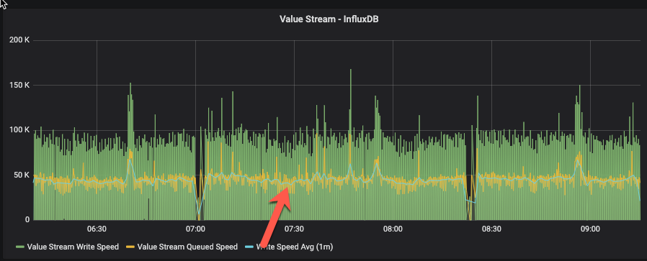

From above 3 example, It's recommended to configure the sampling interval time at 30s, or anything larger than 20s. You can then choose whether you need additional queries based on visualization result.

#### Step 11, Further refinement.

The above charts illustrate the queueing and writing speed. However, it is possible that the Value Stream may perform at a reasonable speed, but value stream queue may be growing and could exceed its capacity.

Let's add another query to monitor this:

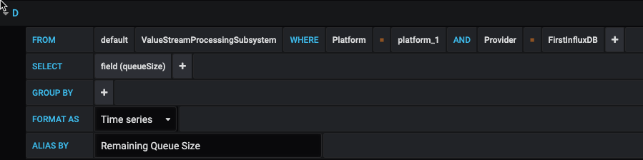

However, it's difficult to read this chart since it has a different value range on the y-axis:

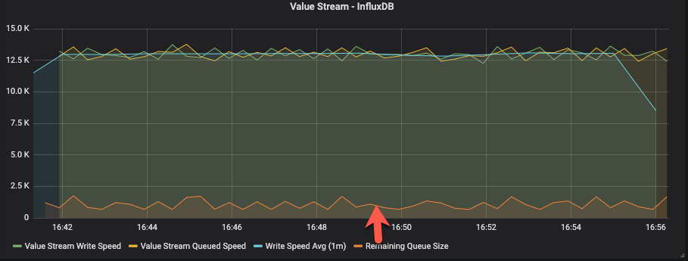

so, let's move this query to a second y-axis on the right:

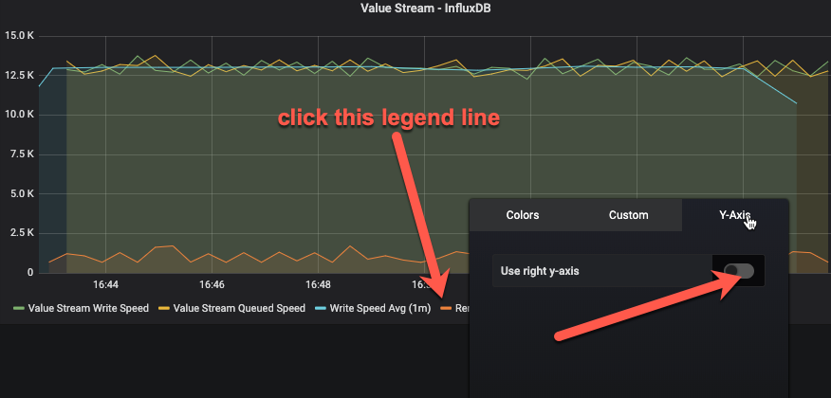

This will make the view much easier to see:

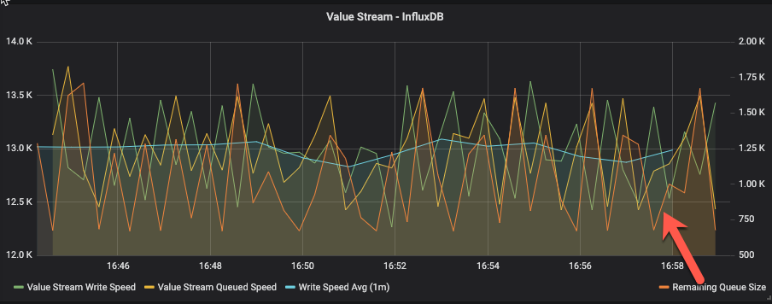

Current queue size or remaining queue size will always move up and down; it is healthy as long as it does not continue to grow to a high level.

### What else can be monitored.

Following metrics would be monitored very often:

* Value Stream Write speed
* Value stream queue speed
* Value stream queue size
* Stream write speed
* Stream queue speed
* Stream queue size
* Event performed speed (completedTaskCount)
* Event submited speed (submitedTaskCount )
* Event queue size
* Websocket communication
* Websocket connection

### Thingworx Memory Usage monitoring

Let's create a new panel and add a new query:

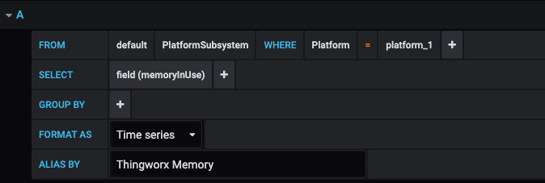

in a running system, memory usage will always move up and down - at times sharply (or quickly) - when system is busy. The system is healthy as long as memory doesn't go up continuously or stay at maximum for a long period of time.

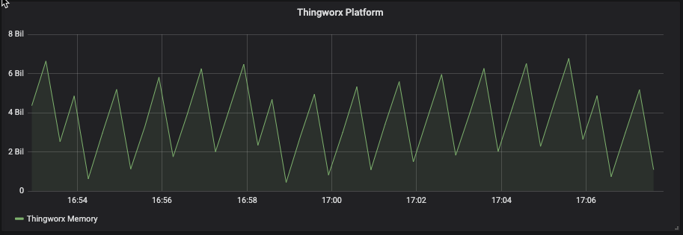

### There is more...

More monitoring tips will be added in future documentation release.